  VALUE INTEGRATOR | MAINTENANCE  WORK INSTRUCTION | MAW02
 | Blanking line Washer  unit clutch clearance | Rev: 0.0
 | Blanking line Washer  unit clutch clearance | Date 30/01/2009

No. | DEFECTS | COUNTERMEASURES
 | THE MAGNETIC CLUTCH ON THE WASHING UNIT WAS OVERHEATING DUE TO MISSALIGNMENT | AFTER THE REMOVAL OF THE CLUTCH GUARD,  IT WAS DISCOVERED THAT THERE WAS  INSUFFICIANT CLEARANCE BETWEEN  THE CLUTCH COUPLINGS INNER AND  OUTER PARTS THUS CAUSING FRICTION  RESULTING IN THE HEAT BUILD UP
 | THE CLUTCH IS DRIVEN BY A CHAIN CONNECTION TO THE LEVELLER 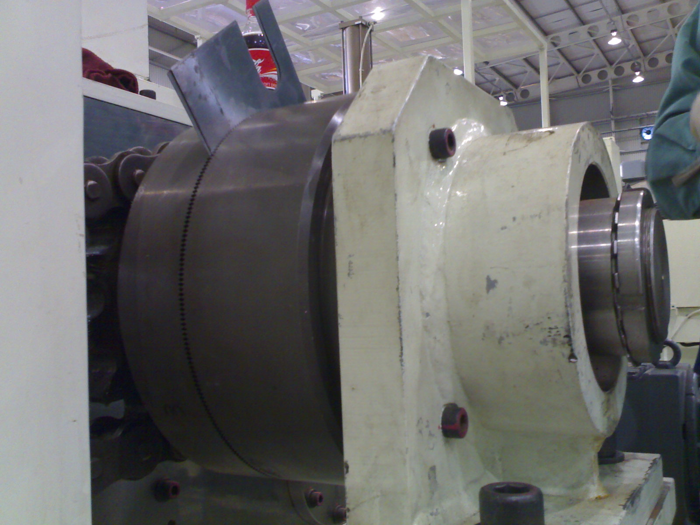 | AFTER DISSINGAGEMENT OF THE CLUTCH AND  LOOSING OF THE HOLDING DOWN BOLTS THE GAP BETWEEN THE TWO COUPLINGS WAS RESET TO  1MM ALL ROUND AND A GAP ESTABLISHED BETWEEN  THE INNER AND OUTER PARTS OF THE COUPLINGS  BY MEANS OF A FEELER GAUGE AGAIN EQUAL GAP  ALL ROUND
 | 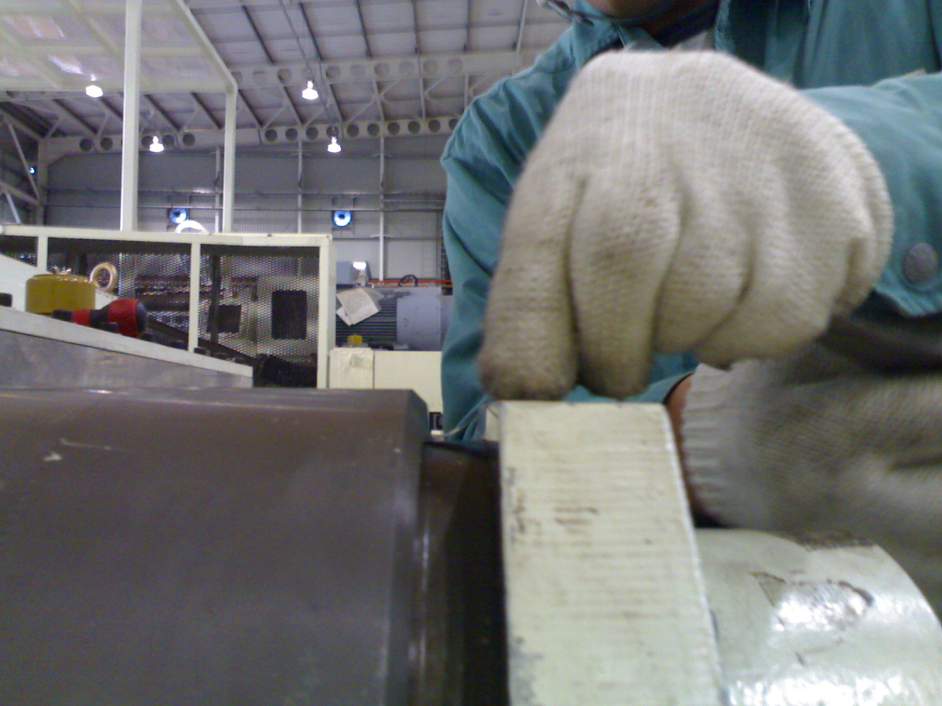 | AFTER THE HOLDING DOWN BOLTS HAVE BEEN FASTENED AND THE CLUTCH RE-ENGAGED A  FEELER GAUGE MUST BE USED TO CHECK FOR CLEARANCE BETWEEN THE INNER AND OUTER  PARTS OF THE COUPLING { MAKE SURE THERE IS AN EQUAL GAP AROUND THE COUPLING }

